Student Id

Database Modeling Project

|  |  |
| --- | --- |
| **Student ID Number** | S00062204 |
|  |  |
| **Programme Title** |  |
|  | Computing Technologies |
| **Module Title** | Data Modelling & SQL Language |
|  |
| **Module Code** | QAC020C155H |
|  |
| **Module Convener** | Ifeoluwa Agboola |
|  |
| **Coursework Title** | New University Project |
|  |
|  |  |

**Academic Declaration:**

*Students are reminded that the electronic copy of their essay may be checked, at any point during their degree, with Turnitin or other plagiarism detection software for plagiarised material.*

|  |  |  |  |
| --- | --- | --- | --- |
| **Word Count** |  | **Date** | 16/07/2020 |
| 1650 | **Submitted** |
|  |  |

Contents

**Introduction:** 1

**Understanding of Databases:** 1

Database Management System: 1

Advantages of Database Management System. 2

Disadvantages of Database Management System: 2

Data Warehouse System: 2

Advantages of Data Warehouse System: 3

Disadvantages of Data Warehouse System: 3

Network Model: 3

Hierarchical Model: 4

Relation database Model 5

Top down and bottom up approaches: 5

**Conceptual Model:** 6

**Logical Modeling:** 7

**SQL and Database Implementation:** 10

**References:** 15

# **Introduction:**

In this era of technology, data is of great importance. The data is involved everywhere in our daily Life. Few examples of databases are:

* Our Mobile Contact Number directory uses a database to store the Contacts in the phone.
* When we search for some keyword or query on google. It fetches the information from a database.
* When we purchase a book or a product online, our information gets stored in a database for the records and delivery purpose.
* Facebook also stores the information of its members and manipulates the data depending upon our following and friends and show that data to us.

There are a countless number of examples of database that can be provided and discussed.

# **Understanding of Databases:**

Before jumping on the advantages and disadvantages of both database management systems and data warehouse systems. Let’s discuss what their uses are.

## Database Management System:

A database is used to store real time information regarding one particular domain of your business. It involves daily transactions such as create, edit, delete records from the database. The database is used to handle a lot of queries on regular basis.

## Advantages of Database Management System.

* Reducing Data Redundancy: If a change is made it is affected immediately to a database and as a result encountering duplicate data isn’t possible.
* Sharing of Data: In database the sharing of data can be done very easily. Many users from different places across the globe can access the database and make changes in it.
* Data Integrity: This means that the data is consistent and correct. Database management system makes sure that the data is correct across all the database present in the DBMS.
* Data Security: Only authorized users are allowed to access the database. Their authentication is done through username and encrypted passwords before allowing them to access and to make changes to the database.
* Backup and Recovery: The DBMS automatically takes backups and recovery of data. It restores the data to its previous condition in case of system failure

## Disadvantages of Database Management System:

* The cost of hardware and software of implementing a database management system is high and can disturb the budget of an organization.
* Most of the DBMS Systems are complex systems so it requires the users to take appropriate training before using it.
* Sophisticated Calculations can’t be made with the database management system.
* Compatibility of systems is a big issue as well.
* Owners of the data may also lose control on their data raising privacy, security isues.

## Data Warehouse System:

A data warehouse System is based on a large set of data to analyze different results to make an informed decision on the bases of that data. It pulls data from single or multiple resources to and it can be used to extract some insights out of it.

## Advantages of Data Warehouse System:

* Enhanced Business Intelligence: Having access to information from different sources data warehousing can be applied in business intelligence.
* Saves Times: In data warehousing data is persevered from different distinct sources and business owner can query the database without any IT support that saves time and money.
* Generates high return on Investment: Using data warehousing the business owners and investors can make informed decisions and as a result that can generate them high return on investments.
* Forecast with Confidence: Data warehousing allows the organizations to forecast the future results of a decision with confidence.
* Improves decision making process: Data Warehousing has improved the decision making process by making use of historic data in that domain and analyzing the output.

## Disadvantages of Data Warehouse System:

* Making use of new data resources takes time and may lead to high cost.
* Some problems may not be detected for many years that are associated with the data warehouse systems.
* It consists of high maintenance systems that involves extracting, cleaning and analyzing the data.
* The scope of data warehousing system always increase despite high level project management.

## Network Model:

This is a many-many relationship model. Network Model database has many records that are connected to one parent file. This is based on a tree where several branches end up in one parent field and that is upside down.

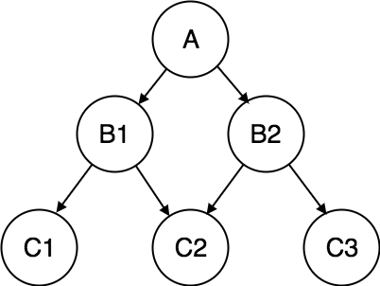

Figure Network Model

## Hierarchical Model:

It has a structure that is very similar to a tree. Between two types of data allows a link with one-much relationship. Each unit has only one root, but one root can have several units. (Fig.2)

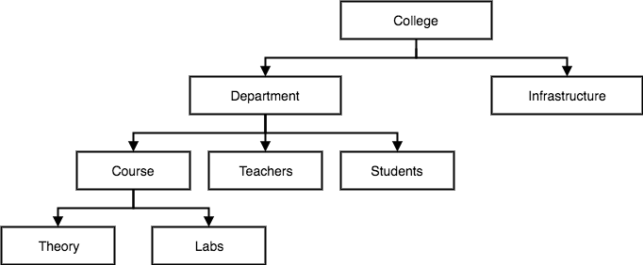

Figure Hierarchical Model

## Relation database Model

The data structure of the relational database modeling system consists of a table, where information about a particular entity (customer) is represented in rows and columns. A Relational database management system (RDBMS) is a DBMS that is based on the relational model as introduced by E. F. Codd in 1970

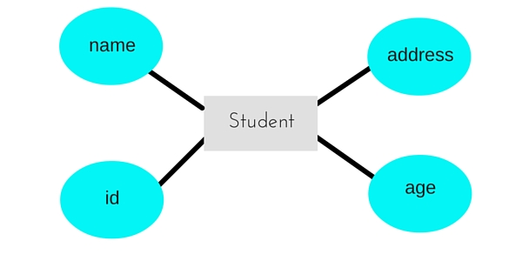

Figure Relational database model

## Top down and bottom up approaches:

There are two main important approaches in the software development process as follows..

**Top Down**

This is related to breaking the problem in small pieces, adding more and more details for each sub-level (top-down or decomposition)

**Bottom Up:**

In this we build the structure by coding and testing step by step without having the complex image of the program and how the parts are linked together (bottom-up). One of the main benefits of the bottom-up approach.

In the present scenario I would prefer the Top down approach since we have the clear end goal of our project and we are aware of the relationships as well. So building up chunk of pieces and adding more detail to each sub module will be better approach to complete this project.

# **Conceptual Model:**

The entities that I have found for this case studies are listed in alphabetical order below:

* Administrators
* Attendance
* Course
* Students
* Tutors

The Conceptual Model diagram using the Crow Foot Notation is as follows

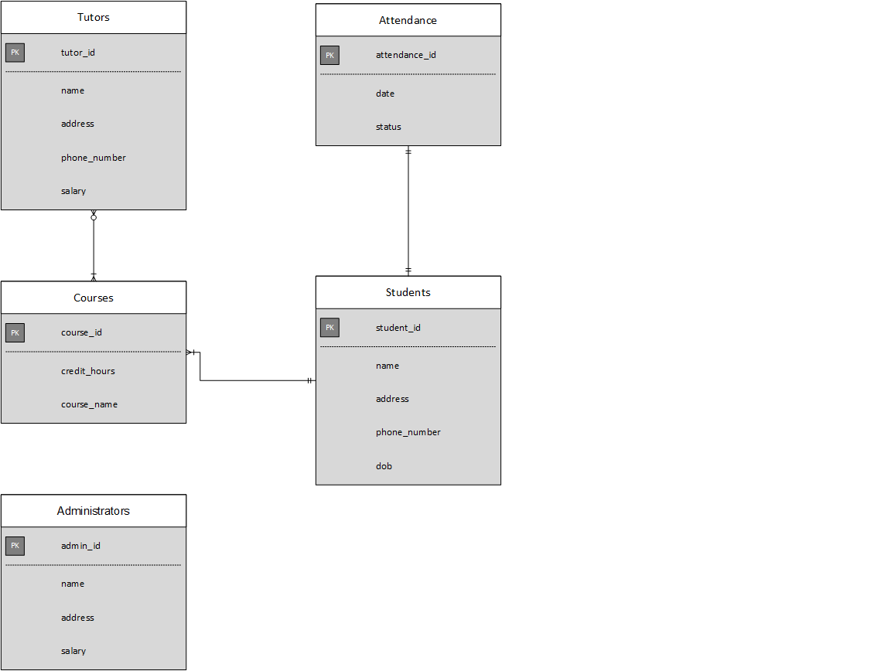

Figure Conceptual Model

# **Logical Modeling:**

**Normalization:**

I followed the normalization rules to normalize the conceptual model. The normalization rules that I have followed are as follows.

**First Normal Form.**

In this normal form I made sure that.

* All attributes columns should be atomic.
* All the values in a column should of the same domain.
* All the column names of a table should be unique.

**Second Normal Form:**

In this normal form I made sure that.

* It’s in first normal form.
* There is no partial dependency.

**Third Normal Form:**

In this normal form I made sure that.

* It’s in second normal form.
* There is no transitive dependency.

The resultant ER Model after normalization is given below:

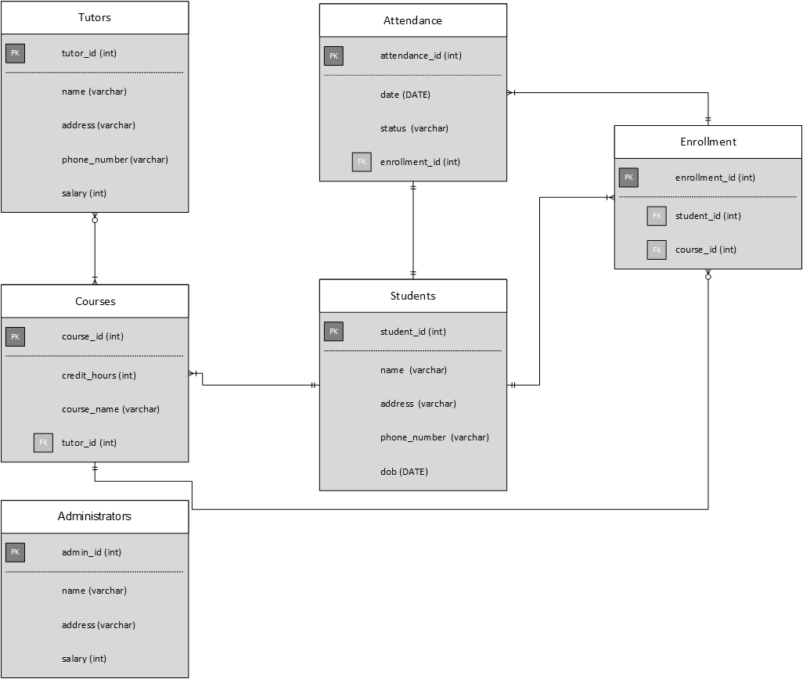

Figure ERD Model (Logical)

The relational model of the case study is as follows:

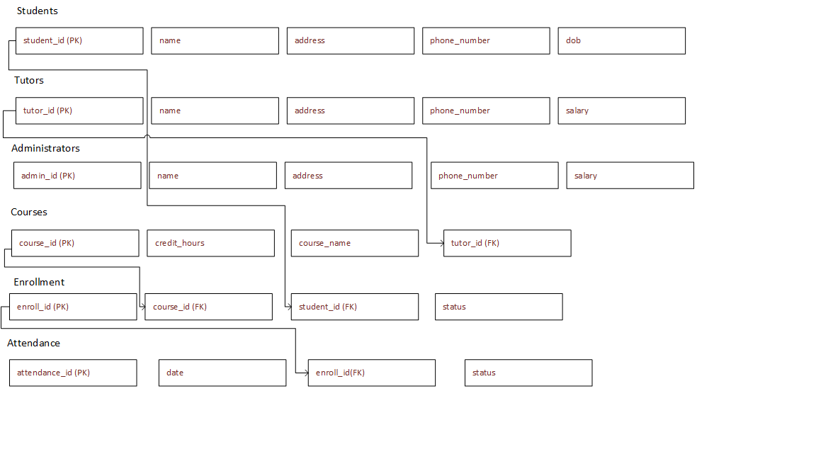

# **SQL and Database Implementation:**

I have made use of MYSQL to implement the database of the case study. I have made use of MYSQL commands such as create to create the database and the resultant tables from the relational models. Also I have made use of the insert command to insert the data into the tables. Alter command is used to alter the structure of the tables such as to apply Foreign Key Constraints and to Set Primary Keys.

The SQL implementation of the database is as follows

CREATE TABLE `administrators` (

  `admin_id` int(11) NOT NULL,

  `name` varchar(50) NOT NULL,

  `address` varchar(100) NOT NULL,

  `phone_number` varchar(15) NOT NULL,

  `salary` int(11) NOT NULL

) ENGINE=InnoDB DEFAULT CHARSET=latin1;

--

-- Dumping data for table `administrators`

--

INSERT INTO `administrators` (`admin_id`, `name`, `address`, `phone_number`, `salary`) VALUES

(1, 'Martin Garrix', 'Manchester Street 5', '440098214215', 12500),

(2, 'Marcel Trek', 'Bristol Street 10', '449281091919', 14300),

(3, 'Geovane Conway', 'Oxford Street 10', '4445124125', 11300);

-- --------------------------------------------------------

--

-- Table structure for table `attendance`

--

CREATE TABLE `attendance` (

  `attendance_id` int(11) NOT NULL,

  `date` date NOT NULL,

  `enroll_id` int(11) NOT NULL,

  `status` varchar(50) NOT NULL

) ENGINE=InnoDB DEFAULT CHARSET=latin1;

--

-- Dumping data for table `attendance`

--

INSERT INTO `attendance` (`attendance_id`, `date`, `enroll_id`, `status`) VALUES

(1, '2020-07-09', 1, 'Present'),

(2, '2020-07-09', 2, 'Absent'),

(3, '2020-07-10', 3, 'Present');

-- --------------------------------------------------------

--

-- Table structure for table `courses`

--

CREATE TABLE `courses` (

  `course_id` int(11) NOT NULL,

  `credit_hours` int(11) NOT NULL,

  `course_name` varchar(100) NOT NULL,

  `tutor_id` int(11) NOT NULL

) ENGINE=InnoDB DEFAULT CHARSET=latin1;

--

-- Dumping data for table `courses`

--

INSERT INTO `courses` (`course_id`, `credit_hours`, `course_name`, `tutor_id`) VALUES

(1, 3, 'Computer Networks', 3),

(2, 4, 'Operating Systems', 2),

(3, 2, 'Database Systems', 1);

-- --------------------------------------------------------

--

-- Table structure for table `enrollment`

--

CREATE TABLE `enrollment` (

  `enroll_id` int(11) NOT NULL,

  `course_id` int(11) NOT NULL,

  `student_id` int(11) NOT NULL,

  `status` varchar(50) NOT NULL

) ENGINE=InnoDB DEFAULT CHARSET=latin1;

--

-- Dumping data for table `enrollment`

--

INSERT INTO `enrollment` (`enroll_id`, `course_id`, `student_id`, `status`) VALUES

(1, 1, 1, 'In Process'),

(2, 2, 2, 'Graduated'),

(3, 3, 3, 'In Process');

-- --------------------------------------------------------

--

-- Table structure for table `students`

--

CREATE TABLE `students` (

  `student_id` int(11) NOT NULL,

  `name` varchar(50) DEFAULT NULL,

  `address` varchar(100) DEFAULT NULL,

  `phone_number` varchar(15) DEFAULT NULL,

  `dob` date DEFAULT NULL

) ENGINE=InnoDB DEFAULT CHARSET=latin1;

--

-- Dumping data for table `students`

--

INSERT INTO `students` (`student_id`, `name`, `address`, `phone_number`, `dob`) VALUES

(1, 'Alberto Carrilo', 'London Street 24', '442142142245', '1996-04-03'),

(2, 'Shakaib Arsalan', 'London Street 92', '44121209897', '1993-02-21'),

(3, 'Kashmala Khan', 'London Street 22', '441298800900', '1993-01-11');

-- --------------------------------------------------------

--

-- Table structure for table `tutors`

--

CREATE TABLE `tutors` (

  `tutor_id` int(11) NOT NULL,

  `name` varchar(50) NOT NULL,

  `address` varchar(100) NOT NULL,

  `phone_number` varchar(15) NOT NULL,

  `salary` int(11) NOT NULL

) ENGINE=InnoDB DEFAULT CHARSET=latin1;

--

-- Dumping data for table `tutors`

--

INSERT INTO `tutors` (`tutor_id`, `name`, `address`, `phone_number`, `salary`) VALUES

(1, 'Yousaf Azhar', 'New York City', '192929105890', 7500),

(2, 'Shakir Ahmad', 'Washington DC', '12929390028', 6800),

(3, 'Joshua Slaubaugh', 'Lords Society UK', '44125125512', 6300);

--

-- Indexes for dumped tables

--

--

-- Indexes for table `administrators`

--

ALTER TABLE `administrators`

  ADD PRIMARY KEY (`admin_id`);

--

-- Indexes for table `attendance`

--

ALTER TABLE `attendance`

  ADD PRIMARY KEY (`attendance_id`),

  ADD KEY `enroll_id` (`enroll_id`);

--

-- Indexes for table `courses`

--

ALTER TABLE `courses`

  ADD PRIMARY KEY (`course_id`),

  ADD KEY `tutor_id` (`tutor_id`);

--

-- Indexes for table `enrollment`

--

ALTER TABLE `enrollment`

  ADD PRIMARY KEY (`enroll_id`),

  ADD KEY `course_id` (`course_id`),

  ADD KEY `student_id` (`student_id`);

--

-- Indexes for table `students`

--

ALTER TABLE `students`

  ADD PRIMARY KEY (`student_id`);

--

-- Indexes for table `tutors`

--

ALTER TABLE `tutors`

  ADD PRIMARY KEY (`tutor_id`);

--

-- Constraints for dumped tables

--

--

-- Constraints for table `attendance`

--

ALTER TABLE `attendance`

  ADD CONSTRAINT `FK_attendance` FOREIGN KEY (`enroll_id`) REFERENCES `enrollment` (`enroll_id`) ON DELETE CASCADE ON UPDATE CASCADE;

--

-- Constraints for table `courses`

--

ALTER TABLE `courses`

  ADD CONSTRAINT `FK_Courses1` FOREIGN KEY (`tutor_id`) REFERENCES `tutors` (`tutor_id`) ON DELETE CASCADE ON UPDATE CASCADE;

--

-- Constraints for table `enrollment`

--

ALTER TABLE `enrollment`

  ADD CONSTRAINT `enrollment_ibfk_1` FOREIGN KEY (`course_id`) REFERENCES `courses` (`course_id`) ON DELETE CASCADE ON UPDATE CASCADE,

  ADD CONSTRAINT `enrollment_ibfk_2` FOREIGN KEY (`student_id`) REFERENCES `students` (`student_id`) ON DELETE CASCADE ON UPDATE CASCADE;

COMMIT;

# **References:**

Shenming, Z., Fanqiang, B., Jianguo, Y., Zhihong, Y., Mei, C., Jinghu, Z. and Yang, C., 2002. Real-time database management system (DBMS) that conforms to IEC 61970 standard [J]. *Automation of Electric Power Systems*, *24*, pp.26-30.  
  
Adendorff, M. and Armstrong, M., Cognos Inc, 2002. *Data warehouse system*. U.S. Patent Application 09/987,905.

<https://www.guru99.com/database-vs-data-warehouse.html>  
  
<https://www.got-it.ai/solutions/sqlquerychat/sql-help/data-definition/ddl-and-dml-commands-in-sql-with-examples-in-mysql-querychat/>